

**INDUSTRIAL TRAINING REPORT**

**AT**

BASENET TECHNOLOGY SDN BHD,

B-01-2 PARAGON POINT @ BICC,

JALAN MEDAN PB5 PUSAT BANDAR,

43650 BANDAR BARU BANGI,

SELANGOR DARUL EHSAN

**BY**

**ISKANDAR ZULQARNAIN BIN HILMI (2017224942)**

**MOHD FURQAN DANISH BIN NOOR HISYAM (2017259234)**

**MUHAMAD SYUKRI BIN ISHAK (2017259146)**

**REPORT**

**SUBMITTED TO**

**FACULTY OF COMPUTER AND MATHEMATICAL SCIENCES**

**UNIVERSITI TEKNOLOGI MARA**

**AS PART OF REQUIREMENT**

**FOR**

**DIPLOMA IN COMPUTER SCIENCE**

**OCTOBER 2019**

**ACKNOWLEDGEMENT**

Alhamdulillah, praise be to Allah for giving us enough time to complete this project. Firstly, we would like to thank Mr. Saifuddin, one of the co-workers, for guiding us throughout the internship, especially on the Basenet Dashboard project. We also would like to thank Mr. Zaril for giving us helpful advices and guidance. We also would like to thank all of the co-workers for being supportive and understanding. Last but not least, appreciation also goes to our beloved parents who have been supporting us throughout the internship.

**CHAPTER ONE**

**INTRODUCTION**

This chapter provides a brief explanation about the company profiles including company background, organizational structure, vision and mission and services provide.

**1.0 Basenet’s Background**

Basenet Technology Sdn Bhd (Basenet) is an ICT system integrator and solutions-based company, a business that provide services to building computing system to client by hardware, software, networking and storage products from variety of vendors. Basenet was first incorporated in 1994 and officially establish in 16 October 1996 owned by 100% Bumiputera. The company was built to fulfil the rapid growth of customer demands and needs in Information Technology (IT) by focusing on end-to-end communications and IT solutions such as hardware and software solutions, structured cabling solutions and support and maintenance services, under the licensed of Ministry of Finance. For the past 20 years, Basenet has been providing a wide range of products and services to address complete information systems requirements of businesses and organizations in ICT industry.

Today, Basenet is in a position to offer a unique range of products and services from software, high-technology-based products and services to specialized industry expertise. Apart from providing highly skilled expertise in Information Technology, Basenet also offers specialized infrastructure-based solutions in accordance with the developments in the world today. Figure 1.0 shows the company location from Google Maps and the road taken daily from home to the office.

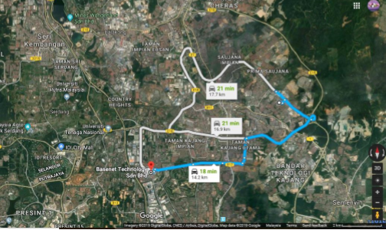

Figure 1.0: Location of Basenet Technology Sdn Bhd. (Source: Google Map)

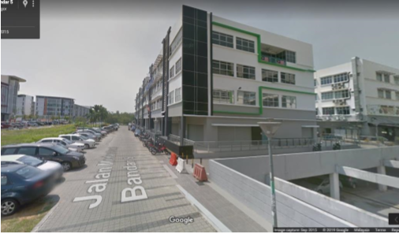

Figure 1.1: Company’s Building from Street View. (Source: Google Map)

**1.1 Basenet’s Logo And Address**

**1.1.1 Basenet’s Logo**

Figure 1.2: Basenet’s Logo



**1.1.2 Basenet’s Address and Contact Number Address**: Basenet Technology Sdn Bhd, B-01-2 Paragon Point @ BICC, Jalan Medan PB5 Pusat Bandar, 43650 Bandar Baru Bangi, Selangor Darul Ehsan

Phone: +603 8929 0000 Fax No: +603 89260 260

**1.2 Basenet`s Organization Structure**

Basenet Technology Sdn Bhd has more than 50 permanent employees with special needed of skill and specialties. This company runs under Managing Director of Basenet, Mohd Rosli Shamsuddin with the help from Faisal Mohd Hussin as a General Manager of the company. Basenet undergoes their business operations by categorized into four departments; Operation Department, Sales Department, Admin and Human Resource Department and Account and Financial Department. Figure 1.3 shows the basic organization chart of the company.

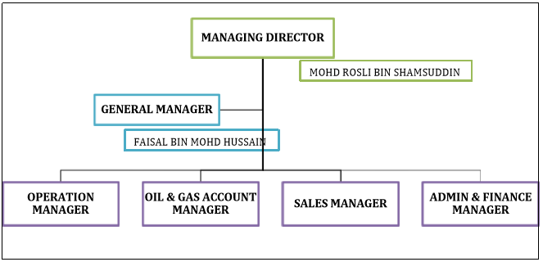Figure 1.3: Basenet Technology Sdn Bhd Organization Chart

**1.3 Basenet’s Service**

There are three types of product and services that Basenet Technology Sdn Bhd provides such as hardware and software solutions, structured cabling solutions and technical support. Product and services were given depend on customer demand and requirement needs, mostly on structured cabling solution and technical support. Structured cabling solutions offer cable-based services, for example data center consultancy, structured cabling system, fiber cabling solution, electrical cabling, copper cabling solution, networking and communications and wired and wireless LAN. Meanwhile, technical supports provide services by monitoring and maintaining system and network for an organization by support and maintenance, system integration and on-site technical support.

1.**4 Company Vision and Mission**

1.4. Basenet Technology Sdn Bhd vision is to be a preferred system integrator and innovative solutions provider.

1.4.2 **Company Mission** We are a market-focused, process-centered organization that develops and delivers innovative solutions to our customers and provide a dynamic environment for our employees.

**Chapter 2**

**System Development and Project**

This chapter gave a summarize version for system and major project that have been assigned by company to me for the entire industrial training session.

**Project Scope**

Within my entire industrial training program, we were placed under guidance of Basenet Technology IT programmer Mr. Saifuddin. Under his advice and counsel, we as a team manage to finish the task given within time period. The task was given to us are mostly to develop a new system for the company. Systems development a part of procedure to either create or upgrade new software application or program by requiring the process of characterizing, planning, testing, and executing. Since Mr. Saifuddin is the only IT programmer in the company, the whole procedure from planning, testing and executing was handled by both of us.

**Task and Project Involvement**

There are 3 main projects that our team involve with for the past two month which is develop a system for Basenet Technology by using PHP. Second task is to assist them in TNB project that placed in UKM. Lastly, project UPM which we have to setup two thousand pc in UPM.

**First project: Basenet Dashboard System**

The system will send a message via Telegram to staff and gave message which Basenet’s website is down or offline. I and my team use Microsoft studio to create the system, so all the codes must be written on PHP language manually. By doing this, I can improve my skill in programming language in MySql and PHP. The target users for this system are the staff from Basenet itself and this system only use to know which website is offline.

**Project Two: TNB Project**

This is the first project where Basenet works together with TNB (Tenaga Nasional Berhad) project. It involves every TNB sites in Peninsular Malaysia. According to our contract with TNB, we provide a service for the installation, configuration and maintenance. By using Aruba as the main product for this project the configuration for the switch might slightly be differ than CISCO product but in term of concept still similar.

The devices were first being sent to the server room. Then it will be resealed again, scan and deliver to the intended site according to their network diagram. By giving the chance to get involved with this project we get the chance to experience the way to handle other switches from CISCO.

**Project Three: UPM project**

In this project we as a team are under Mr Amirul Khairi guidance. We be given a task which we have to setup a new pc from Dell in University Putra Malaysia (UPM). We have to setup two thousand pc in differences faculty in UPM. We also have been given a chance to learn how to setup a new pc, gathering the information of the pc and work as a team.

**CHAPTER 3**

**System Overview**

**Problem Statement**

Recognizing the uptime and downtime of the system is important to smoothen the process inside a business. The company needs a way to find a way to monitor all of their websites. The system must not only show the status of the website but must be able to notify the employees about the change of status of the website immediately.

**Project Objectives**

These are the objectives of the system:

* To show the status of the company’s website whether it is online or offline in real time.
* To allow the users to add, edit, and delete website included in the system.
* To notify the employees about the change of status of the website through Telegram application.

**Project Scope**

The system consists of a webpage that shows a list of websites along with the status and the link of the websites. The webpage will be reloaded for every 5 seconds to refresh the status of the website. The whole system would be mobile-responsive, which means the content can be read without having to change the scale of the website. Another feature of the website is the ability to add, edit, and delete website.

The language used to develop the website are HTML, CSS, and PHP used along with MySQL. With MySQL, database will be created specifically just to store the information of the website including name, URL, and the status of the website.

**System Design**

**User Interface**

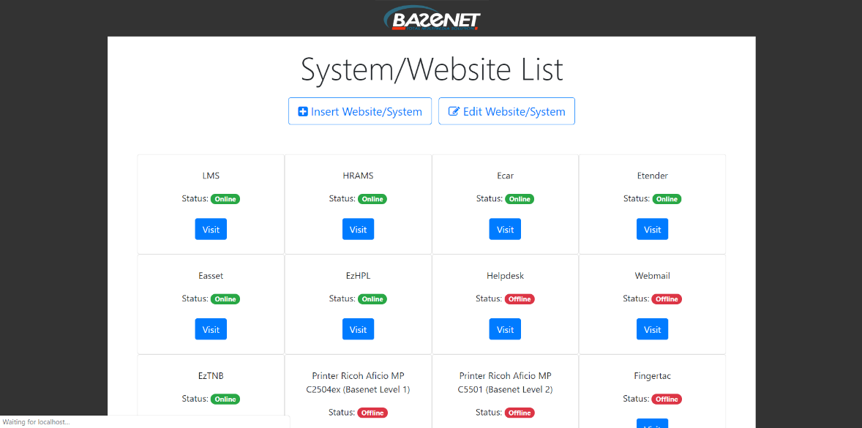

Figure - Homepage of the website

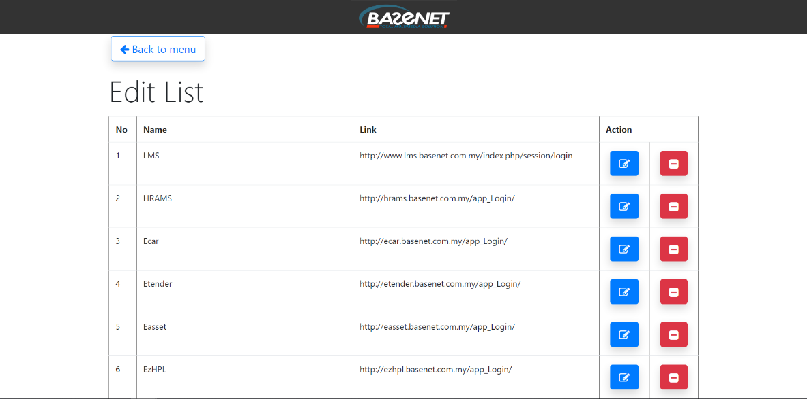

Figure - List of website, which can be edited and deleted

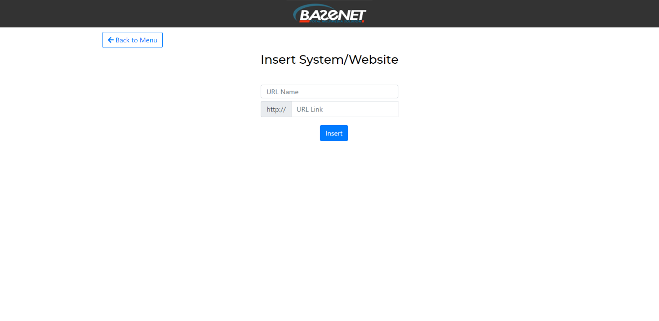

Figure - Insert website

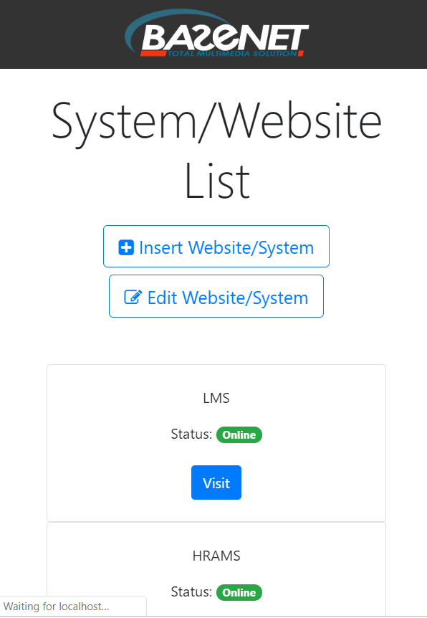

Figure - Webpage in mobile form

**CHAPTER FOUR**

**Project Three: UPM project**

This chapter will provide further details on the third and ongoing project, the UPM Project. This chapter will explain on the tasks given and done during the project.

**4.0 Introduction of the UPM Project**

There was no methodology used during the UPM project as there is no specific methodology brought forward by our supervisor as Basenet Systems and UPM have both reached an agreement on how the project would be done. The objective of this project is to supply, deliver, install and test personal computers for the use of UPM staff and students. The main product vendor used for the project is Dell Technologies.

According to the contract, Basenet agree to provide services to supply, deliver, install and test the products to ensure that all personal computers set up are fully functional and free of errors caused by the operating system. To ensure that this is the case, each personal computer is installed and set up with care and precision. The Windows operating system is checked upon the booting sequence and the activation process is also done by the team sent by Basenet Systems.

**4.1 Delivering the Products to the Sites**

The first task that was given was to help the team that delivered the products by moving the products from the delivery truck to the sites chosen by the UPM staff. We lifted the boxes that contained the personal computers into several buildings that were located at different faculties. We helped the delivery team carry all 2399 boxes of personal computers and the same number of boxes containing the Uninterruptible Power Supply (UPS). The products are delivered in batches over the course of a few days.

**4.2 Setting up the Personal Computer**

When we got permission to start installing the personal computers by UPM we were tasked to bring a specific number of boxes depending on a list provided by UPM for the purpose of installing. We will then open the boxes and check whether each part needed is in the box. We then put the parts together in order to assemble the personal computer. The personal computers are set based on the preference of the UPM staff. We turn it on and let it boot up. We will also lock the personal computers to the tables to prevent theft. This is done by using a high-quality metal cable lock that utilises the Kensington Security Slot that was available on the computers.

**4.3 Testing, Activating Windows and Installing Office 365**

After the personal computers are set up, we will then install the F-Secure Antivirus Software and proceed to activate the Windows operating system. We will open the text file that was already on the desktop screen of the personal computer and it will provide the code for the activation of the operating system. We will then begin to install Office 365 after the process of activation is completed. After all of that is finished, we will delete all the software setup files and empty the recycle bin. We will restart the computer and test whether the system can boot up and run smoothly.